.
PETERSON AIR AND SPACE MUSEUM
FOUNDATION

NEWSLETTER

PRESERVING THE HERITAGE

VOLUME II, NO. 9 JULY 2008

FROM THE PRESIDENT
WES CLARK

This will be my first opportunity to offer some comments concerning the Museum since I recently became the President of the Foundation. I can’t tell you how honored I am to serve in this position. Few people understand just what a jewel the Peterson Museum is – as a historical record of the airfield’s past and as a teaching vehicle for those here now and those still to come.
Over the past years there have been some steady stewards of the Museum’s upward growth path, but I believe that the recent leadership and volunteer staff have been superb in keeping the growth positive and soaring. One has only to look at the additions to the Museum in recent years to understand the significance of the growth path. From a collection of dusty artifacts in poorly maintained buildings some twenty years ago, it has morphed into a true showplace in recent years.
To give credit where credit is due, I want to thank the volunteer staff for their dedication and commitment in making this Museum come alive. I am constantly amazed at the number of hours our volunteers are committing to the upkeep and care of our Museum, and it is to them that we owe so much. It is my hope and belief that we can and will engage a greater population of Peterson AFB and our local community to continue the expansion and growth path that our volunteers have set us upon. We owe that to them and to ourselves.

WHO AM I
ED WEAVER

I was manufactured by Lockheed Aircraft, Burbank CA and delivered to the USAF on 14 May 1958. I was designed and designated TP-80C as the result of the alarmingly high accident rate of the P-80. Our maiden flight was on 22 March 1948. A month later my designation was changed to TF-80C. After 128 of us were built we got yet another designation on 5 May 1949. No less than 5,691 of us were produced in the US while 210 by Japan and 656 more in Canada. Production continued until 1959. We were everywhere serving with Air Forces of no fewer than 30 nations.
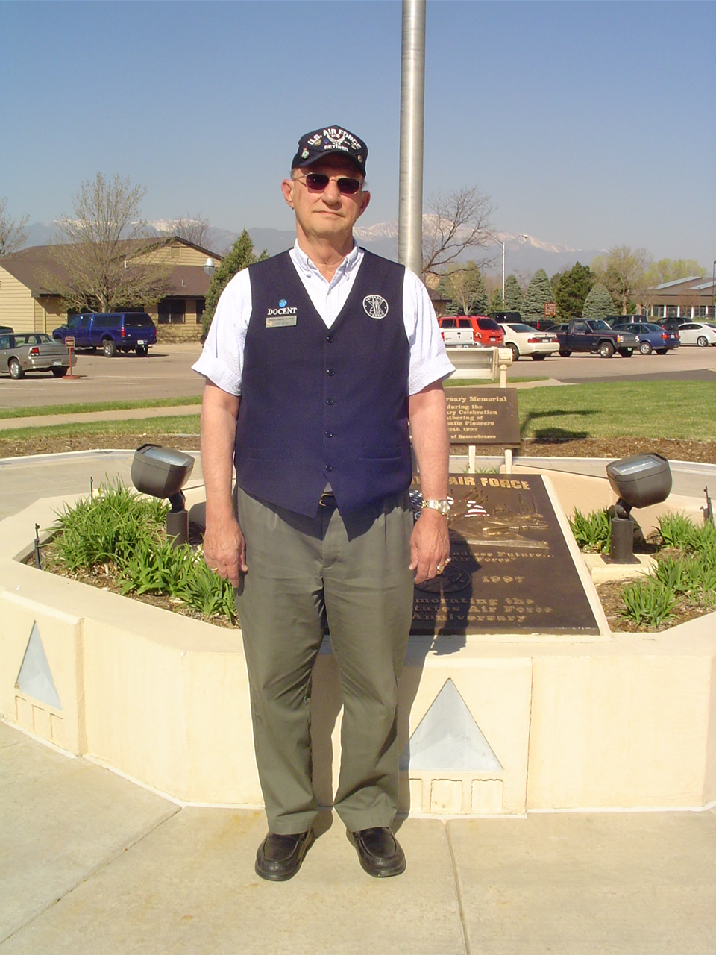
My initial assignment was with the 3300th Flying Training Wing (ATC), Randolph AFB, TX. By March 1961, I was flying with the 3510th FTW but still at Randolph. I was off to the Air Defense Command’s 75th Fighter Interceptor Squadron at Dow AFB, Maine during January 1965. Next stop found me at the 4780th Air Defense Wing, Perrin AFB, Texas. After three years I was off to the 325th Fighter Weapons Wing at the Air Defense Weapons Center, Tyndall AFB, FL, for a seventeen year tour of duty. I than found my way to the Military Aircraft Storage and Disposition Center at DM AFB AZ in March 1988. My records get a bit fuzzy after that, but it is assumed that I came to Peterson AFB, CO, in December 1990, and was assigned to the 302 Airlift Wing. I was used for aircraft battle damage repair training until the fall of 1995 when at a stroke of luck I “landed” at the Peterson Air & Space Museum. They have taken good care of me since and repainted me in the Air Defense Center colors.
Recently I got new neighbors…three HAWKS. By now you should have guessed…….. I’m T-33A Shooting Star S/N 57-0713, perhaps one of the most successful trainers ever to roll down a runway.

MEET OUR VOLUNTEERS
JACK MCKINNEY

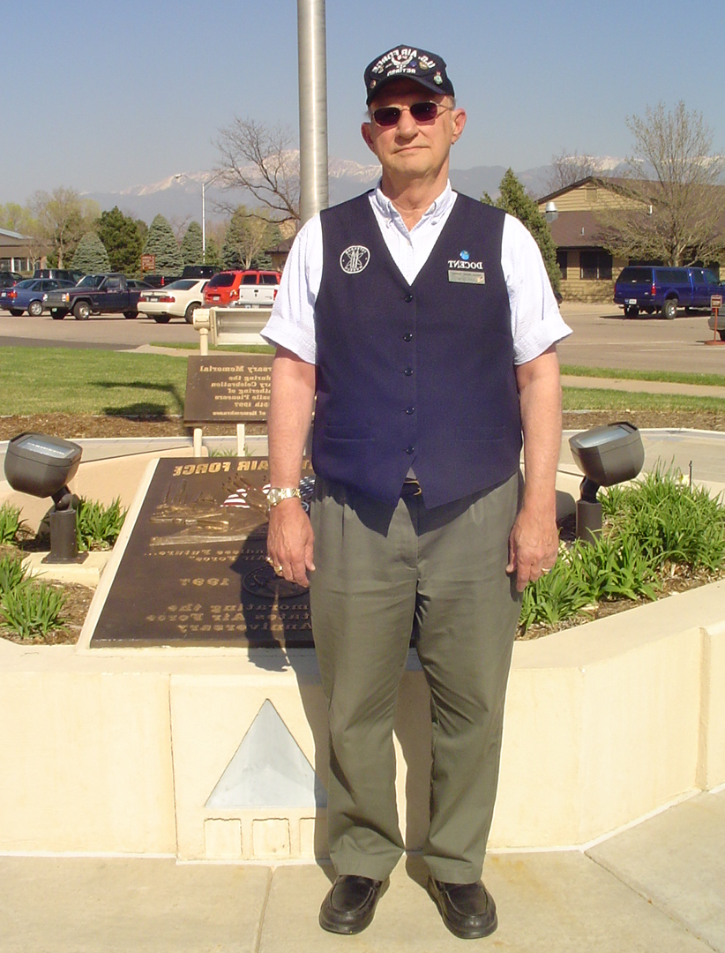
MSGT JOHN GRIER
USAF RETIRED

MSgt John Grier was born 25 September 1941, in Reading, PA; he graduated from Reading Senior High School in June 1959, and joined the United States Air Force that same month. John’s basic training was accomplished at Lackland AFB and Amarillo AFB, TX.
After Supply Tech School at Amarillo, John went back to Lackland where he worked in the “Green Monster” issuing clothing to new basic trainees. That was where he met his wife, Mary Elizabeth
He transferred to Greenland in 1962, assigned to the 32 FIS, in the maintenance control section. From there, in 1963, it was back to Texas at Dyess AFB where he worked in the inventory management branch of Base Supply until 1968, when he was assigned to Sembach AB, Germany with the 601st Tactical Control Group until 1972.
From there it was back to Bergstrom AFB, TX, and into a new career field – Disaster Preparedness – which is now called Readiness, under the Civil Engineers for NBC, disaster response actions. During that assignment he was an augmenter for HQ, 12th AF Inspector General Team inspecting TAC bases.
Next, in 1972, he was transferred to RAF Mildenhall, UK, where he remained for 11 years, again augmenting the HQ USAFE IG team, seeing may TDYs all over Europe. For eight years, John was a volunteer crewman on the only flying B-17G in Europe, the “Sally B”, which took part in air shows and working movies for British television, and also movies such as “Memphis Belle” where the “Sally B” played the role of the “Memphis Belle”. Also, as a member of the Military Vehicle Conservation Group in the UK, he made six trips to the continent to re-enact famous battles, such as Normandy, Bridge too Far, Battle of the Bulge, etc. He is still active with the “Sally B” crew and member of numerous aviation restoration/historical organizations.
Upon his return to the USA in 1983, John was assigned to the HQ AF Space Command IG team, for the next two years traveling the world inspecting AFSC bases and units. He retired in 1985, and went to work for Raytheon in their base supply contract at Peterson AFB. That was followed by a stint working for Contel/GTE in their logistics division for the GPS satellite project.
In his last 14 years until total retirement in 2003, John was with the Harrison School district as warehouse/distribution supervisor. He now enjoys his volunteer work at the museum, and collecting die cast scale model aircraft and model railroading, with his membership in the Centennial American Legion Post 209, and the Civil Air Patrol.
John and Mary Elizabeth , still happily married after 45 years, have two children, Denise and David and two grandchildren, TJ and Haley, now both in their teens.

ARTIFACT OF THE QUARTER
JACK MCKINNEY

In June 1963, President John F. Kennedy visited NORADHeadquarters at Ent AFB, as well as visits to the other military forces in the Colorado Springs area.
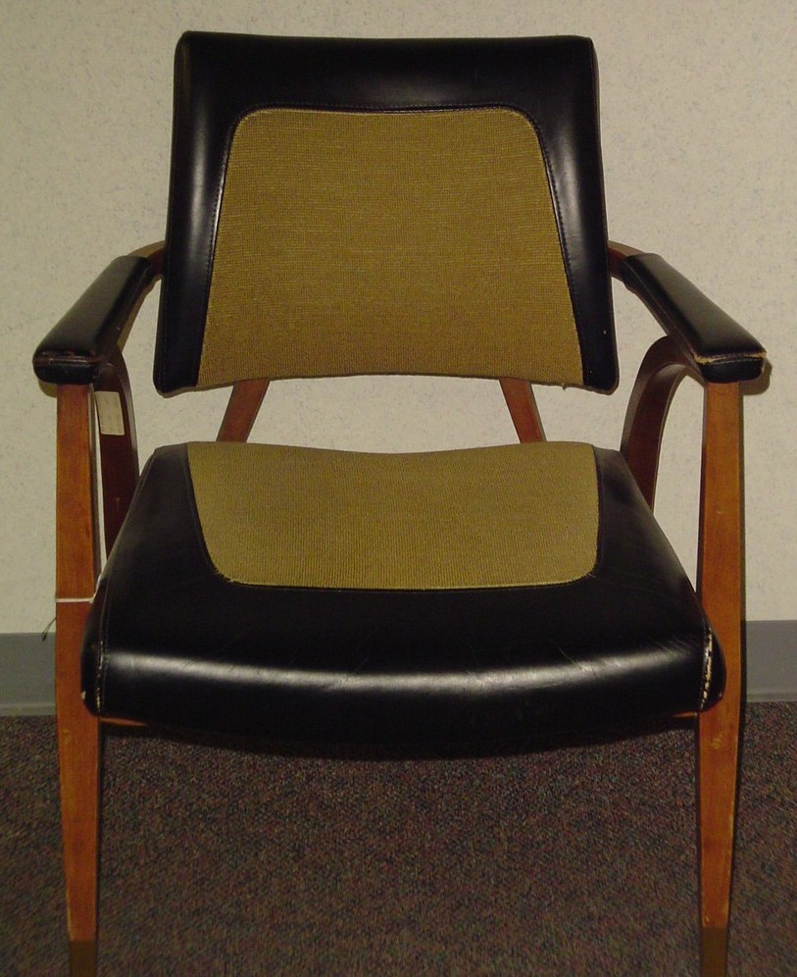
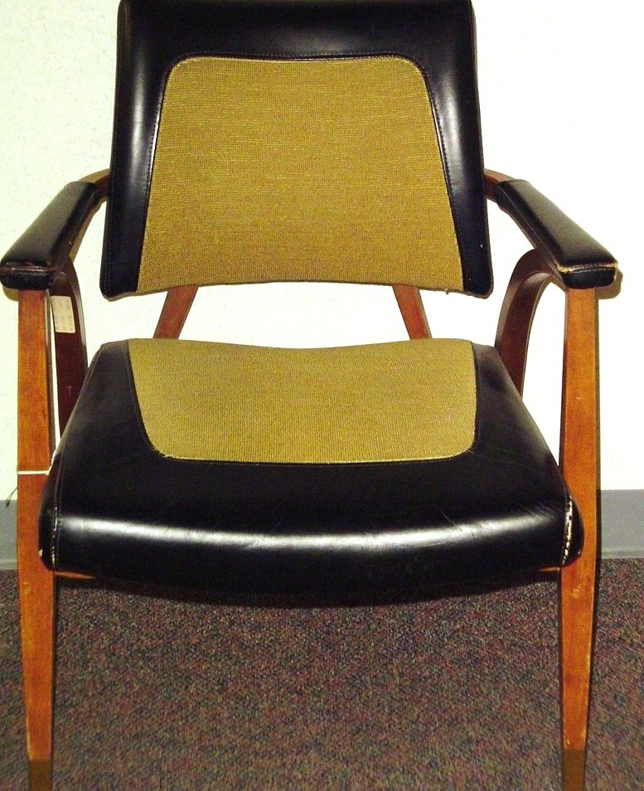
Among the points of interest to the President was the still-under-construction Cheyenne Mountain complex, where excavation was nearly complete and building construction was just beginning.
Hosting the President were General John K. Gerhart, CINC NORAD, and Lieutenant General Robert M. Lee, Commander Air Defense Command. The chair pictured here was provided for President Kennedy, whose back problems were well known.

THE CHAIR

GALAXY OF STARS
JACK MCKINNEY

The Peterson Air and Space Museum at Peterson AFB, Colorado, has established an Air Defense Galaxy of Stars to honor and commemorate the thousands of United States and Canadian military personnel who manned the air defense facilities and weapons systems of our nation.
During the existence of the Air/Aerospace Defense Command from the post war 1940s until its disestablishment in 1980, and into the present day, ground environment units, fighter interceptor squadrons, airborne early warning and airborne warning and control units, and missile units manned the outposts of air defense from coast to coast and from the shores of the Caribbean to the shores of the Arctic Ocean. Supplementing their efforts were personnel of Army Air Defense Command and Navy picket ship and fighter units. Also involved were those who served in air defense forces in Alaska, Greenland and Iceland.
All those dedicated men and women earned a place in our countries’ history as they assured the air defense of a continent during the long days and nights of the Cold War, and into the present. Many such units were in places very few would willingly want to call home; nevertheless they served, they watched, they waited, and they made our skies safe for the citizens of our Nation and Canada.
Now, they will be recognized and remembered forever as the Air Defense Galaxy of Stars becomes a living memorial to each and every one of them in the Peterson Air and Space Museum.
To become a member of the Galaxy of Stars any military member of the United States Air Force, Army, Navy or Marines as well as Canadian Forces personnel who ever served in any of the following commands are invited to become honorees: Air Defense Command, Continental Air Command, US Army Antiaircraft Command, US and Canadian Ground Observer Corps, Eastern Air Defense Force, Central Air Defense Force, Western Air Defense Force, Continental Air Defense Command, Army Air Defense Command, Alaskan Air Command/Alaskan NORAD Region, Naval Forces Continental Air Defense Command, Canadian Air Defense Forces, Air Forces Iceland, Aerospace Defense Command, North American Air/Aerospace Defense Command.
Submit request for inclusion as follows:
Provide clearly identifiable photograph in an authorized uniform – said photograph to be 4” X 6” (or croppable to 4X6)
Provide full name and highest rank held
Provide job titles, AFSC/MOS (brief description of duties if desired)
Provide unit designations and locations of one or all air defense units in which service was rendered
Submissions may be edited and will be appropriately displayed within the Air Defense Exhibit at the Peterson Air and Space Museum for visitors to view (submitted materials will not be returned unless accompanied by a request for return and a self addressed and stamped envelope). Material should be addressed to Galaxy of Stars, Peterson Air and Space Museum, 150 East Ent Avenue, Peterson AFB, CO 80914, or, via e-mail to: ronmcclelland@comcast.net.

DOROTHE PETERSON
ED WEAVER

The Foundation made a contribution to the Alzheimer’s Association in the memory of Dorothe Peterson who passed away during May 2008. She was the wife of Lt Col Maurice D. Peterson, USAF (Retired) brother of Lt Edward J. Peterson, USAAF, Both Dorothe and Maurice have been frequent visitors and strong supporters of the Museum. Our thoughts and prayers go out to the family.

DIRECTOR’S REPORT
GAIL WHALEN

I want to thank all the Peterson Air and Space Museum volunteers and staff for a great start to the Summer of 2008. We’ve accomplished an incredible amount, and look to continue that progress this year. We’ve added upgrades to our exhibits, installed an impressive Cheyenne Mountain tunnel entrance look-a-like; welcomed the Army as they adopted our air defense missiles; provided displays for the NORAD Anniversary jubilee; and walked off with about a dozen of their fantastic images to use in the NORAD exhibit.
We’ve been visited by the Air Force Vice Chief of Staff, General Frank Klotz; the senior curator of the National Museum of the Air Force, Mr. Terry Aitken; and the Secretary of Defense, Mr. Robert Gates. We provided support for the Department of Defense Legacy Program (let them see how a historic district is supposed to look on a military base) and the General Lemay Best Services in the Air Force inspection team.
Our Board members have secured funding and significant donations from the Association of Air Force Missileers, Northrup Grumman, and Boeing corporations. Through it all, the volunteers have flown cover and been the best wingmen the 21st Space Wing could ask for. I’m grateful everyday for the work you do. This could be the year when we “git ‘er done!”
MPT DEDICATION SUCCESS
It’s not a real exhibit opening if there isn’t some paint still drying, or a poster being delivered just before show time, or someone comes out of the back room carrying a model and chanting like the Israelites carrying Joseph’s bones to the Promised Land. This happened on May 9th, as the 21st Space Wing and the Peterson Museum Foundation dedicated the Peackeeper Missile Procedures Trainer at the Museum’s Old City Hangar. Foundation Board Member Tim McMahon was also able to acknowledge the donation from Northrup Grumman for our display of the DSP satellite in the Missile Warning Exhibit.
Guests included General Robert Kehler, commander of Air Force Space Command; Major General Roger Berg, Commander of 14th Air Force; Charlie Simpson, executive director of the Association of Air Force Missileers, and the wing commanders and competitors from all three Missile Wings attending the Guardian Challenge competition at Peterson AFB.
It was a captive but appreciative audience, as old timers mingled with and dazzled the young competitors with tales of derring do, Crits versus HQ’s, brown trouts and silent running. In short, the dedication provided the experience that we hoped for from our Museum: a place where the exhibits let people talk to each other about their experiences. Our thanks again to all the volunteers who put in many hours to assemble the MPT and Peacekeeper ICBM re-entry vehicle shroud and put together an outstanding display.
STATIC DISPLAY UPDATES
The CF-100 “Canuck” is finally getting the paint job she deserves. Contractors performed walk-around inspections the week of June 23. We expect to have her painted, complete with all her correct Canadian Air Forces markings, by the end of August. Besides the F-101 Voodoo that used to guard the West Gate, the Canuck needed the most serious paint work of all our static displays. Vive la Canada!
Speaking of the F-101, we have confirmed from the 21st Space Wing that our Voodoo will be installed at the East Gate’s Peak View Park, across from the BX/Commissary complex. The new setting will include “wayside” exhibits, which is a fancy way of saying we’ll be able to put some detailed story boards around the aircraft. The new static display will feature a belly cradle instead of pylons going up the engine exhausts. It will still be in “flight” attitude, but closer to the ground—easier for the public to see it and volunteers to maintain it!
The F-4 Phantom will get patched up this Summer as well. The stabilators (correct term) will be removed and replaced in August, with the help of our Big Brothers at the 302nd Air Wing and 21st Mission Operations Squadron. The 302nd is even going to do some touch up painting for us. Would you believe the interior of a C-130 is painted the same color as the exterior body of our F-4? Another breakthrough for our F-4: assistant director Jeff Nash located intact wings, flaps and radome in Arizona’s “Bone Yard.” If the 21st Space Wing has the funding available at the end of the year (September), we’ll bring the parts here.
The Minuteman III Intercontinental Ballistic Missile (ICBM) will be gracing Peterson AFB this year. Air Force Space Command General Robert Kehler has released funding to the 21st Space Wing to bring a Minuteman to the base from the depot in Utah. The Minuteman will be displayed vertically (“keep the pointy end up,” a famous missileer slogan) near Building 1470, at the intersection of Otis Street and Peterson Boulevard. The missile will be displayed in “warrior colors” as it would appear in the silo. It should make its appearance peacefully on the base in mid –August, with emplacement date to be determined.
FACILITY REPAIRS
Drainage improvements behind Building 981 (Terminal Building)begin the week of June 23rd. Contractors will be removing portions of the concrete patio and flower beds behind the building (facing the airpark), then digging under to the foundation walls of the east side of the building. They’ll seal any damage, back fill the soil, and install more drains to slough the water away from the building. This will address two major problems: water flooding the patio and into the lobby; and water leaking into the basement which floods the floors and destroys the retaining walls. It also means that if we have to “shelter in place” in the basement during an emergency or base exercise, we won’t have to cling to the ceiling like Spiderman to avoid possible electrocution as the water seeps through the electrical outlets. And finally, as part of this project, contractors will emplace the newest set of Commemorative tiles around the flagpole.
SPORTING NEWS FROM CIVIL ENGINEERING
Bulldozer vs. Gas Line, ends in Bulldozer 1, Gas Line Zip! On June 18th, a bulldozer carrying a new condenser for the malfunctioning air conditioner in Building 982 (‘The Broadmoor Hangar’) snagged the natural gas line and popped the line open. Wing civil engineers made a quick escape, ran to nearby buildings (including the Museum Terminal) and got emergency responders there in a heartbeat. It was a great real-world exercise: our staff (TSgt Dishion) and docents (Jim Palmer, Gus Freyer, Gordon Scott) were able to evacuate the buildings and get our visitors safely out of the airpark. I was really proud of everyone. Next time, though, could someone maybe come look for me and let me know my building is about to explode? Apparently I was the only person left in the building as the leaking gas flowed RIGHT INTO MY OFFICE!!
Woodpeckers vs. Hangar Door Insulation, another blowout as the Woodpeckers completely shut out (or opened up a commanding lead) against the Insulation! Its true, the Great Northern Flicker, a beautiful woodpecker about 11 inches tall, has managed to pull ALL the insulation off the top of the Hangar doors. The yellow fiberglass apparently dampened his love calls. We’ll get the insulation replaced, but meanwhile, let the staff know if you see any small birds in the Hangar, and we’ll shoo them out.
Yellow Jackets Beat Connie In a Four to One Blow-out! Yellow jacket wasps have been swarming the four engines on the EC-121T Warning Star for about a week straight. On June 20 they began to move down the fuselage towards the passenger door. Apparently they wanted docent Jim Bowden to give them a tour. Base Environmental officers asked that we keep the Warning Star closed until the exterminator could come take a whack at the wasps. He came, he squirted, he did not conquer. The wasps were back the next day. (We blame the Ramp Rats for this. If they hadn’t done such a good job sealing the Warning Star engines from the birds, the yellow jackets would never have had an opportunity to colonize.)Please be cautious as you approach the Warning Star until we remove all the wasps over the next few weeks.
Sun’s Violent Rays No Match for Wonder Film and Curtains. We’ve finally won one. In an effort to block the Sun’s invisible ultra-violet light from entering the Museum’s Old City Hangar, TSgt Dishion has installed UV-blocking film on the inside of the windows, and UV tubes on the fluorescent lights. This 3-M film is able to block 97% of the UV spectrum. UV causes slow but steady irreversible damage to our artifacts. In order to add a further layer of protection to the Museum’s historical property, and also to allow our visitors a better viewing experience, we’re also adding curtains inside the window frames. This two-pronged approach should help reduce the temperature, cut down on glare, and help reduce UV degradation of the exhibits.
ADOPT-A-PLANE SUCCESS AGAIN THIS YEAR
Assistant director Jeff Nash has gotten good response from the Adopt-a-Plane “parents” this Spring during our second year of the program. As an added bonus, he found the US Army Space Command’s 1st Space Company willing to tackle the Nike Ajax and Hercules missiles. They not only cleaned and polished the missiles, but they put the Air Force to shame, as they showed up in Battle Dress and put a spit and polish on those missiles not seen since they were installed! BEW-YAH ARMY!
NATIONAL MUSEUM INSPECTION TEAM TO VISIT SEPTEMBER 8 - 19
As we’ve mentioned in the past, the National Museum of the Air Force is sending a team to Peterson Air and Space Museum to perform a wall-to-wall inventory of our facility in preparation for our Museum Certification inspection next year. This is a critical step in our ability to continue operating as a Field Museum for the Air Force. The team from Wright Patterson will be here from 8 - 19 September. It’s our busiest time of the year, but I know all the work and preparation by our staff and volunteers, headed by the Inventory Team (Jack McKinney, Charlie McCarthy, Skip Lynette, Jim Swalley) will bring us success. If you have a chance during their visit, please come by and meet the Wright Patterson team.
AIR DEFENSE WORKING GROUP
I want to thank the volunteers who are putting their time and effort into developing the Air Defense exhibit for the Museum’s Old City Hangar: Jack McKinney, Gus Freyer, John Brown, Scott Lee, Ed Weaver, and Erv Smalley are doing the lion’s share, but I know many of our volunteers are providing them with research as well. This is the year we want to complete as much of our CORE exhibits as we can, even if we do keep tweeking them after they’re in place. I know these guys are going to see this through if they have to kill the Director to do it.
1ST SPACE COMPANY CLEANS MISSILES
JEFF NASH
The US Army has joined in the fun with the museum’s Adopt-A-Plane program. On June 12th, Soldiers from the 1st Space Company, 1st Space Battalion here at Peterson AFB came out and gave a much-needed cleaning and polish to the museum’s Nike Ajax missile display. 1st Company is part of the Army Space and Missile Defense Command, and has committed to coming out periodically and keeping both Nikes squared away for the future. You can see these Soldiers in action on the museum’s web site at: http://www.petemuseum.org/WD12Jun08Page01.html
Not to be outdone, the following Saturday I was assisted by our junior docent Trent Harding and his friend Cody in giving the olive drab booster section of the Nike Hercules missile a good clean and polish. Made quite a difference.
RAMP RATS REPORT
JERRY KOVACH
The repairs to the tail section of the F-4C will begin in earnest by the end of July. You may remember the F-4 received some “battle damage” from an errant base landscaping contractor driving a tractor. Replacement horizontal stabilators are in hand, and the AF Reserve’s 302Nd Aircraft Maintenance Squadron here at Peterson will lend a big hand to get them installed. Just as soon as the right experts complete a short deployment to the desert. The 302nd’s Aerospace Ground Equipment shop has also offered to help us do some repairs on the MD-3 ground power unit on display next to the F-106. There are all kinds of smaller jobs on the “to do” list, ranging from replacing fading decals to applying preservative on aircraft tires. There’s never a dull moment.
MUSEUM NOTES
Tom Allee has received confirmation from Medal of Honor recipient Col Bud Day USAF (Retired), who is also an ex POW, that he will attend the Peterson Air and Space Museum’s Medal of Honor Grove ceremony to be held 18 Sept 08. Please mark your schedule accordingly...more details to follow.
Our new ICBM Exhibit continues to receive attention. The 3 Jun 08 “Air Force Association”' Magazine's Daily report. outlines the Peacekeeper missile and construction of the Museum's Peacekeeper Missile Procedures Trainer (MPT). The web site also links to the Air Force Space Command's Web Site's Home page which features the ceremony at the Museum. You may view both stories by clicking on dailyReport@afa.orgon

* * * * * * * * * * * * * * * * * * * * * * * * * * * * * * * * * * * * * * * * *
The Peterson Air and Space Museum Newsletter is published by the Colorado Springs Peterson Air and Space Museum Foundation, Inc., a private entity no way connected to or with the United State Air Force. Contents of the Newsletter are not necessarily the official views of, or endorsed by, the U. S. Government or the Department of the Air Force.

* * * * * * * * * * * * * * * * * * * * * * * * * * * * * * * * * * * * *
G. Wesley Clark, Maj Gen (USAF, Retired), President

Jack L. McKinney, CMSgt (USAF, Retired), Editor

Peterson Air and Space Museum Foundation, Inc.
150 East Ent Avenue
Peterson AFB, CO 80914
www.petemuseum.org
* * * * * * * * * * * * * * * * * * * * * * * * * * * * * * * * * * * * * * * * *

Peterson Air and Space Museum
150 East Ent Avenue
Peterson AFB, CO 80914

